

**INDIVIDUAL ASSIGNMENT**

**TECHNOLOGY PARK MALAYSIA**

**CT010-3-1-FSD**

**FUNDAMENTALS OF SOFTWARE DEVELOPMENT**

**APU1F2006CS(IS)**

**SIM YOKE SHIN TP059851**

**HAND OUT DATE: 17TH AUGUST 2020**

**HAND IN DATE: 20TH SEPTEMBER 2020**

**WEIGHTAGE: 100%**

**INSTRUCTIONS TO CANDIDATES:**

1. Submit your assignment online in MS Teams unless advised otherwise
2. Late submission will be awarded zero (0) unless Extenuating Circumstances (EC) are upheld
3. Cases of plagiarism will be penalized
4. You must obtain at least 50% in each component to pass this module

**Table of Contents**

|  |  |  |
| --- | --- | --- |
| No. | Title | Page Number |
| 1. 1 | Introduction | 3 |
| 1. 2 | Assumption | 4 |
| 1. 3 | Design of the program   * Pseudocode * flowcharts | 5 |
|  | Program source and explanation | 33 |
|  | Screenshots of sample input/output and explanation | 45 |
| 1. 4 | Conclusion | 55 |
|  | Reference | 56 |

**Introduction**

|  |  |  |
| --- | --- | --- |
| Module (Code) | Division and Sections | Warehouse Code |
| Bios(BS) | Engine Section(ES), Air-conditioning Section(AS), Safety and Cockpit section(SC) | WBS |
| Ambry(AY) | Engine Section(ES), Air-conditioning Section(AS), Safety and Cockpit section(SC) | WAY |
| Barrier(BR) | Engine Section(ES), Air-conditioning Section(AS), Safety and Cockpit section(SC) | WBR |

This report is a documentation for the planning of an Automobile Parts Inventory Management System for an automobile manufacturing plant of Hondi Motor Company Limited Partnership (Hondi Co.) in Johor. Due the economic slowdown, the company has assembled all assembly division of cars into three modules named Bios (BS), Ambry (AY), and Barrier (BR).There have provide a warehouse for each module likes WBS warehouse for Bios, WAY warehouse for Ambry, and WBR warehouse for Barrier. Besides that, each warehouse that use to store 3 types of assembly sections named ES, AS, and SC. Thus, the main purpose of this report is designing the new automobile parts inventory management system and explant about all parts of pseudocode, flowcharts, and code of it.

**Assumption**

Hondi Co. has stored all the assembly parts in different warehouse according with its section. All the assembly parts are supplied by some famous assembly parts supplier’s company likes Robert Bosch GmbH, Aisin Seiki Corporation, Denso Corporation, and ZF Friedrichshafen AG. Hondi Co. has gotten the parts of ES section from Aisin Seiki Corporation, get the parts of AS section from Denso Corporation. The parts of SC section are provided by Robert Bosh GmbH and ZF Friedrichshafen AG.

The three main function of the automobile parts inventory management system is update parts inventory function, tracking parts inventory function, and searching function. Inside the update inventory function, the users can update the inventory for different warehouse. The company has extra stored a function for input the details of Suppliers. The update inventory function is design to input the addition parts for different warehouse’s sections. The second main function is design for tracking the parts inventory. The users can choose either they want to print the details of whole parts that is store in the company or print the part’s details which quantity is almost out of stock or just print the current warehouse’s parts that they want. The last main function of this system is search function. It has provided three different ways for user to search likes search the parts, search the supplier details, and search the parts that supplied by supplier.

**Design of program**

Parts Inventory Creation in Warehouses and Update

Pseudocode:

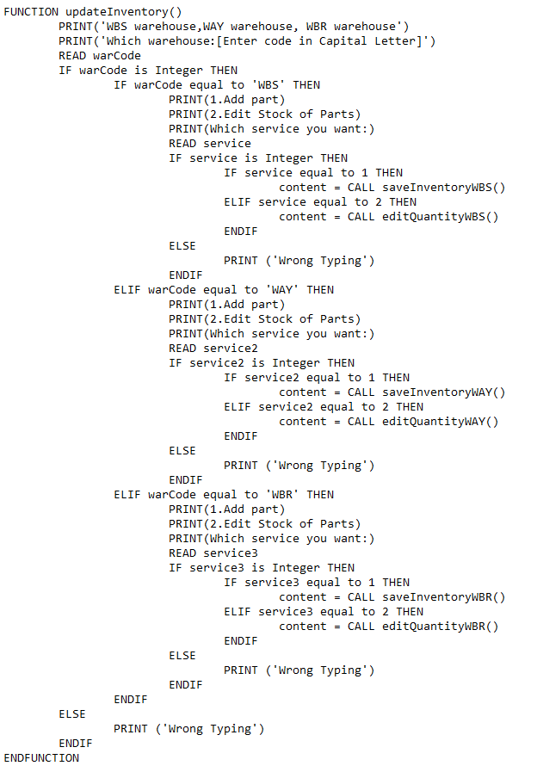

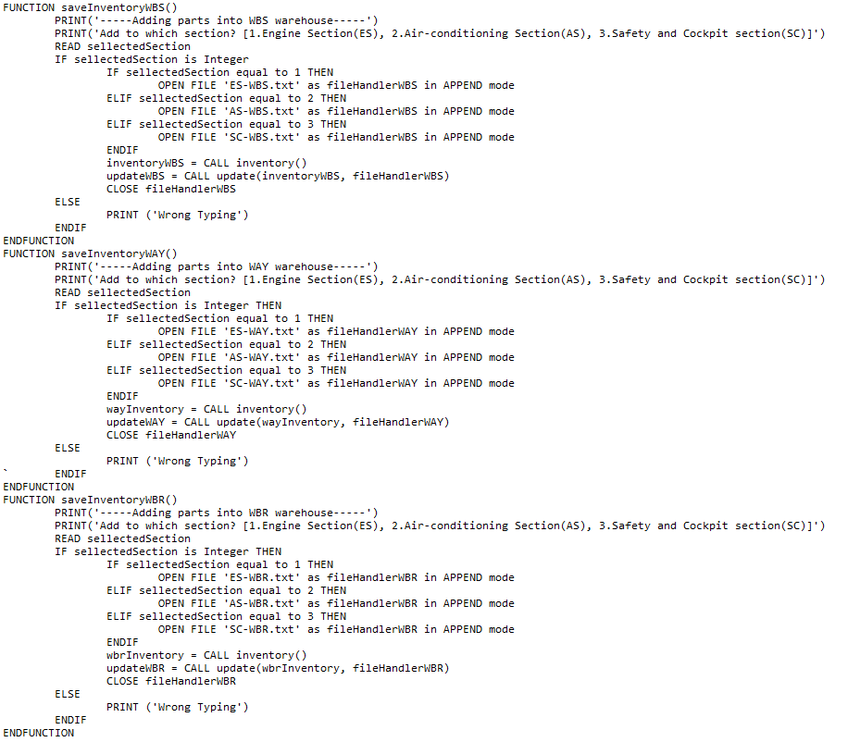 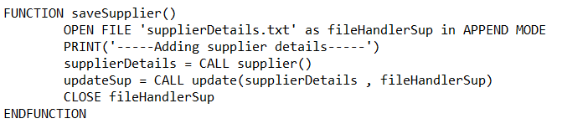

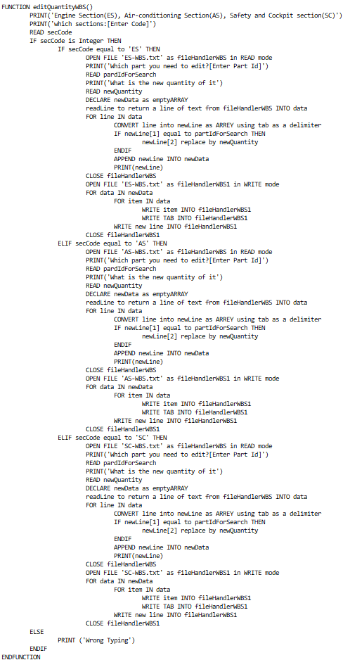 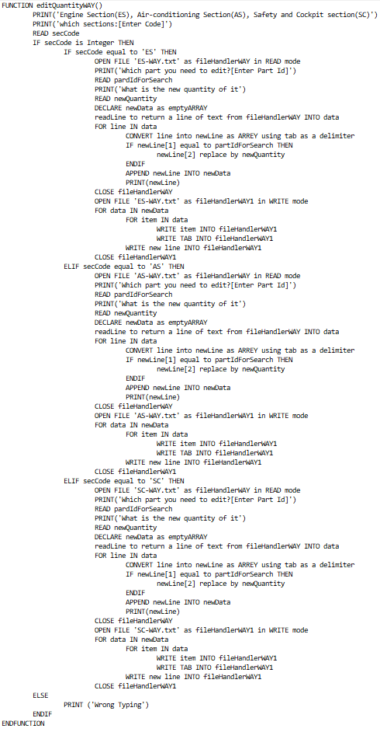 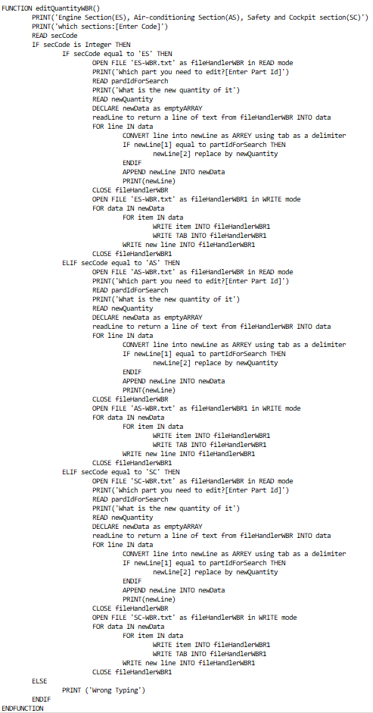 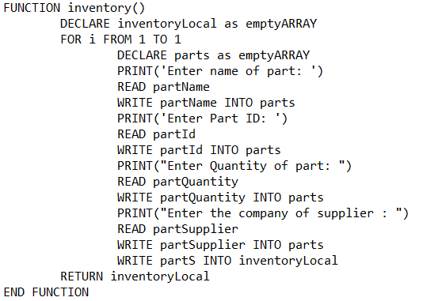

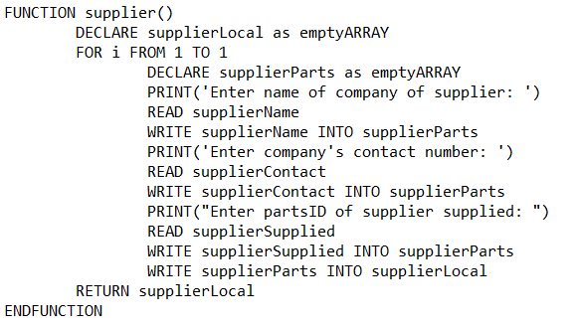

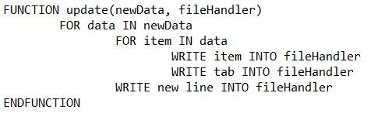

Flowcharts:

updateInventory():

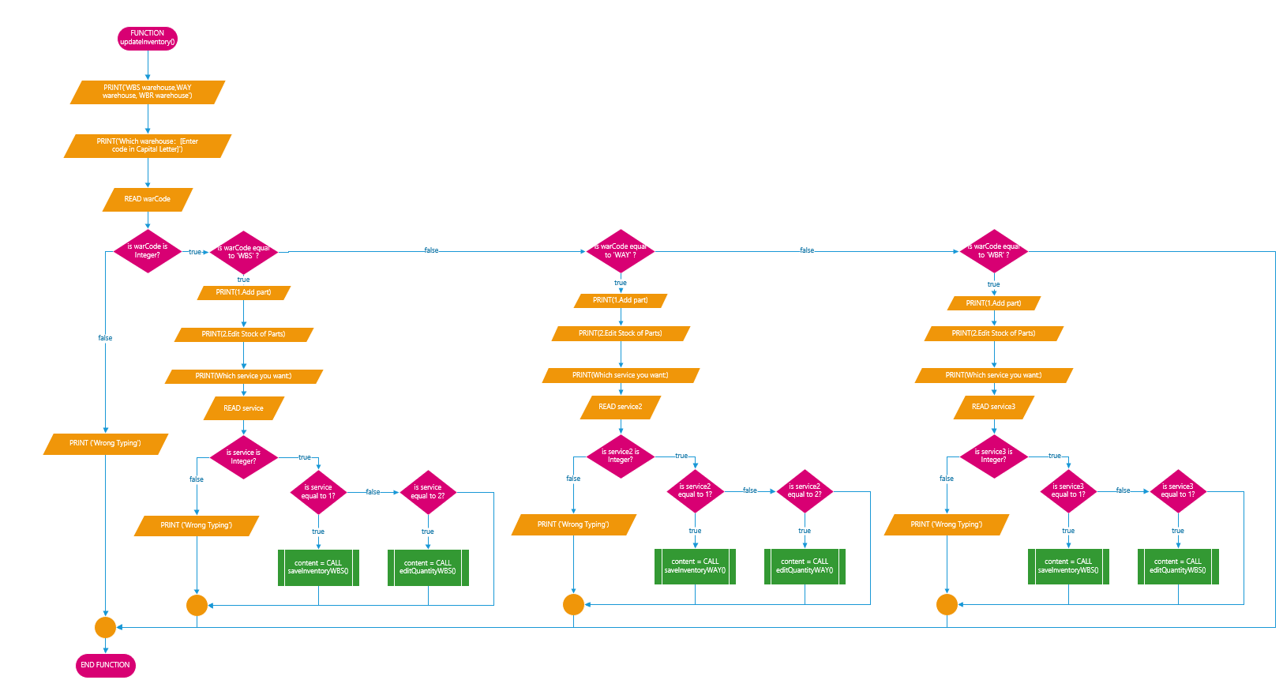

saveSupplier():

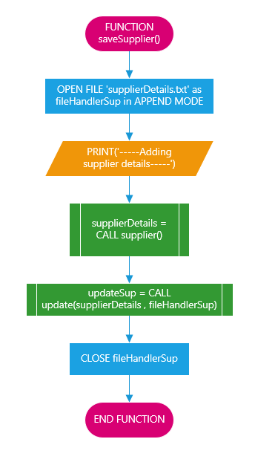

saveInventoryWBS():

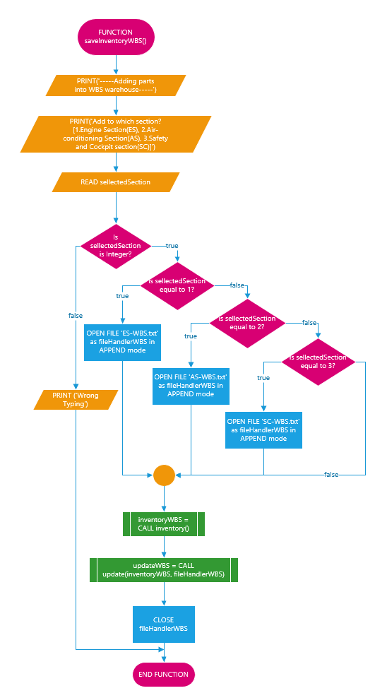

saveInventoryWBR():

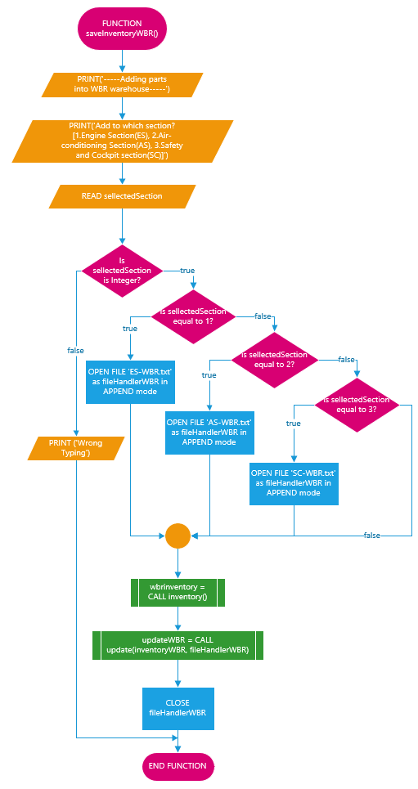

saveInventoryWAY():

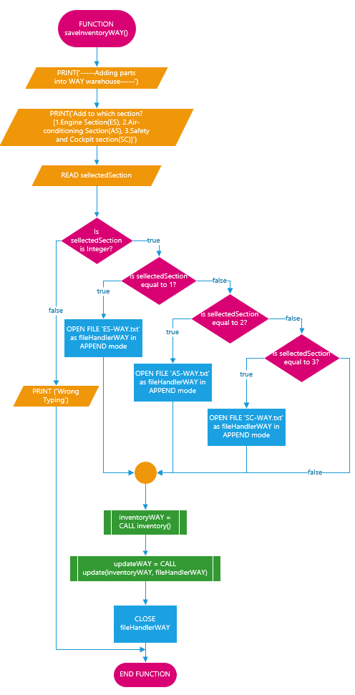

editQuantityWBS():

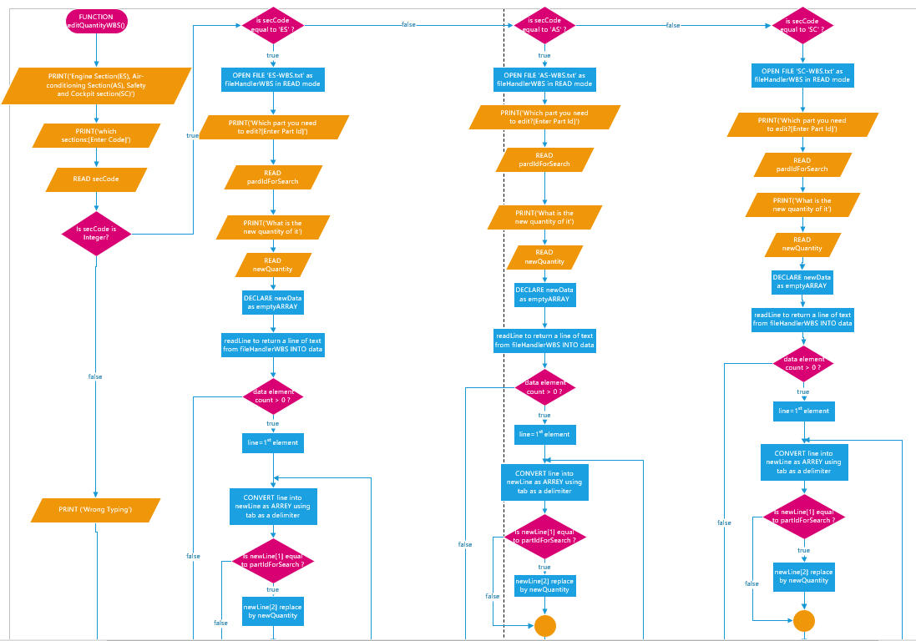

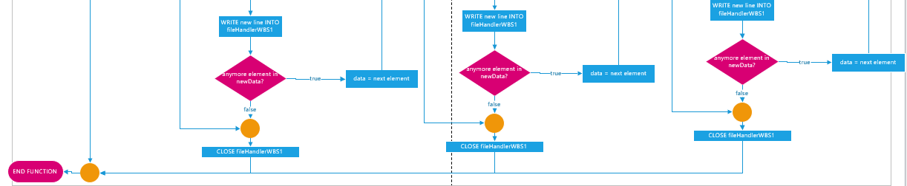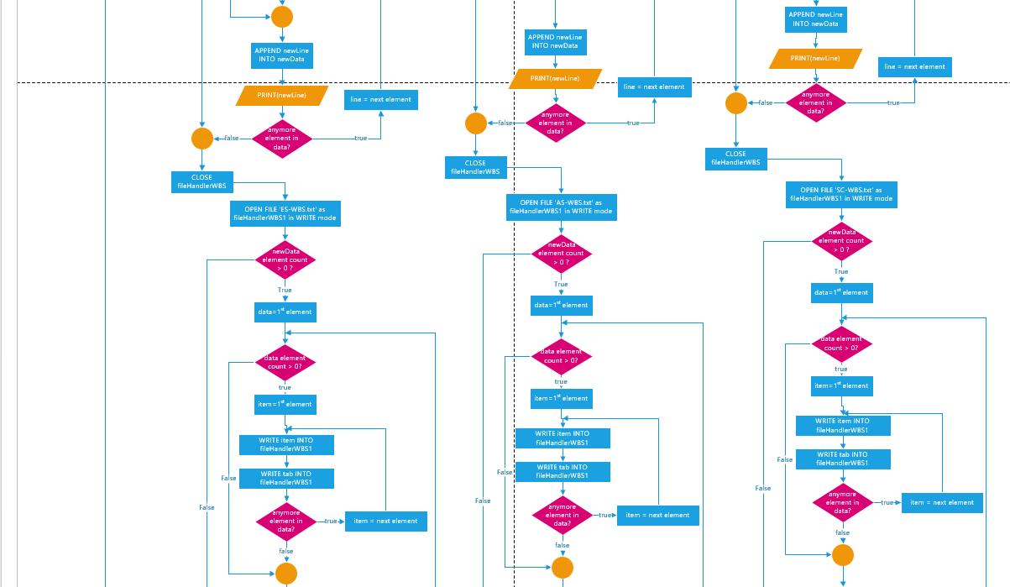

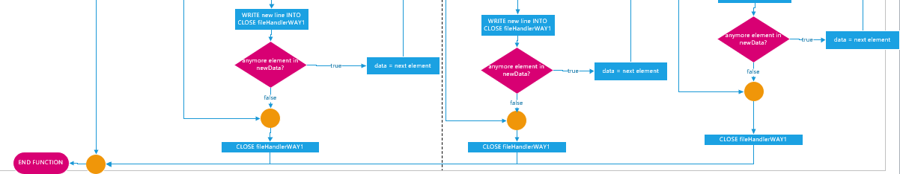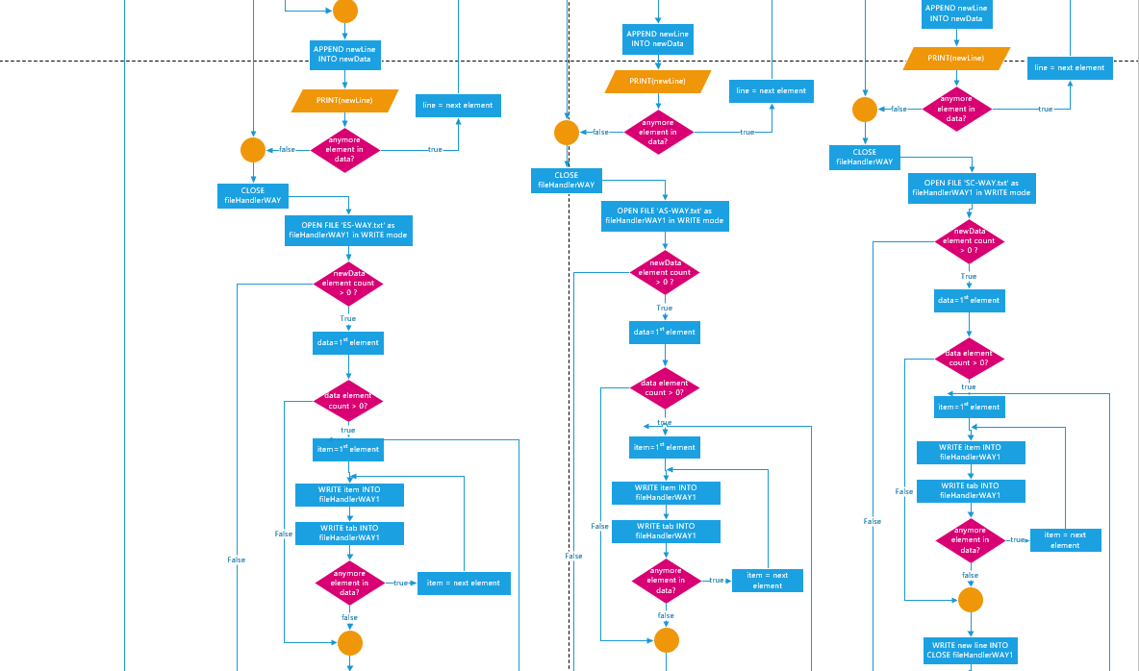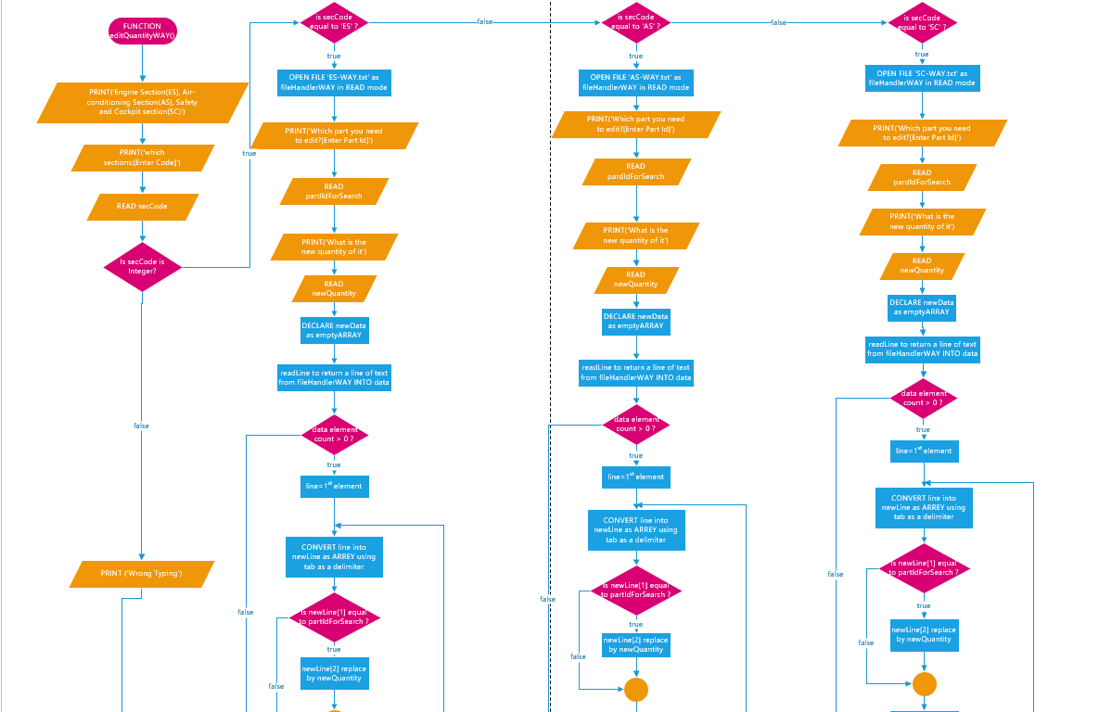editQuantityWAY():

editQuantityWBR():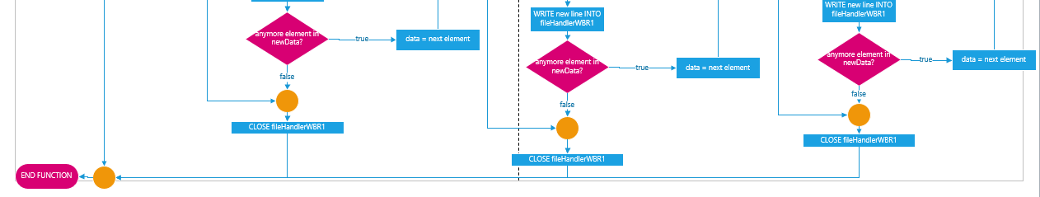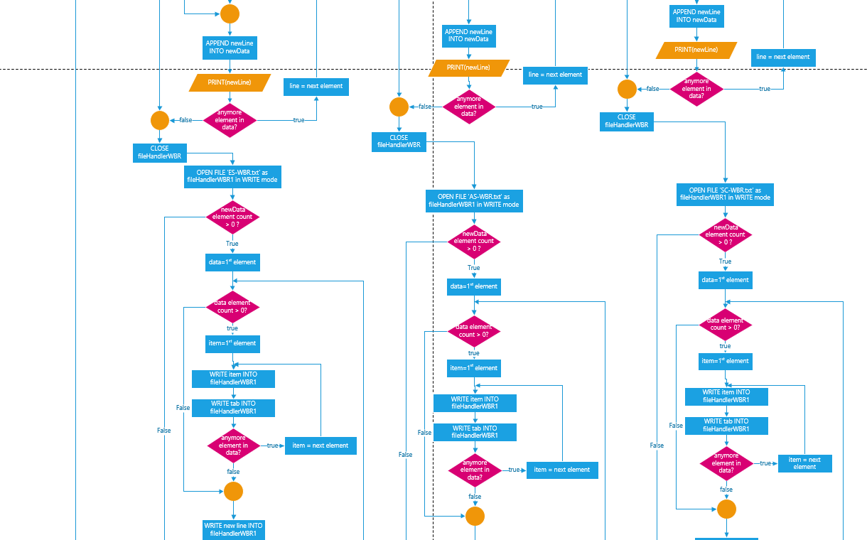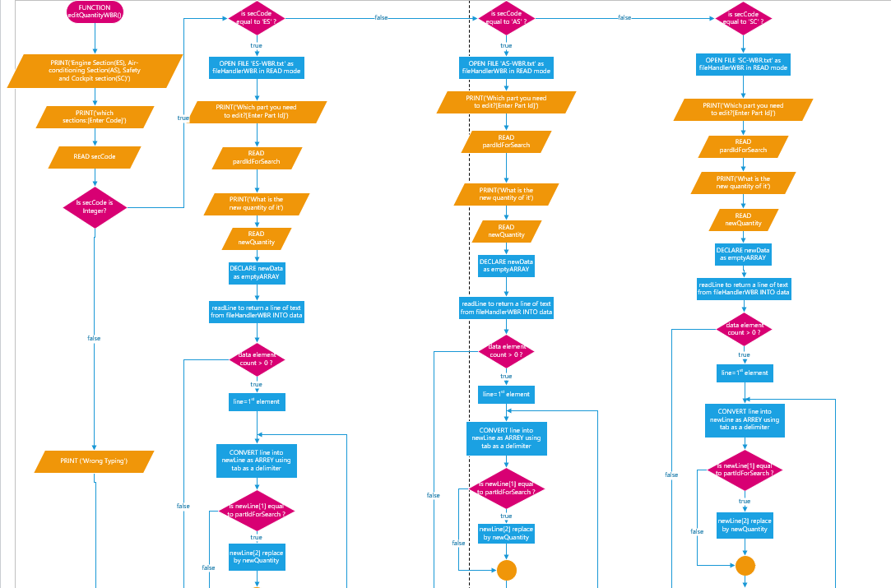

inventory():

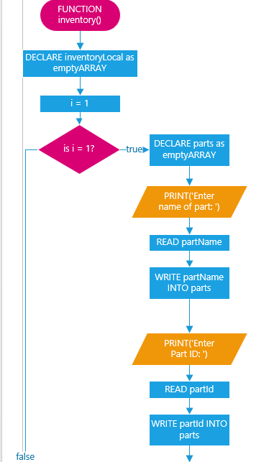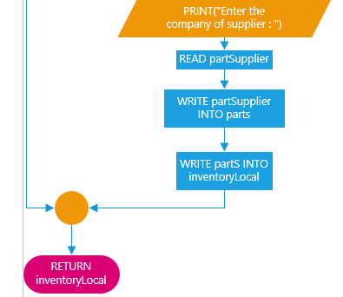

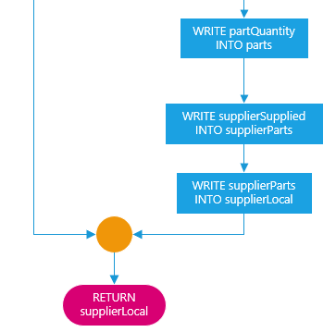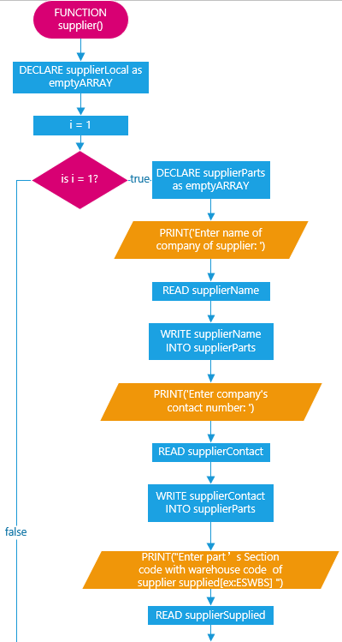supplier():

update(newData, fileHandler): 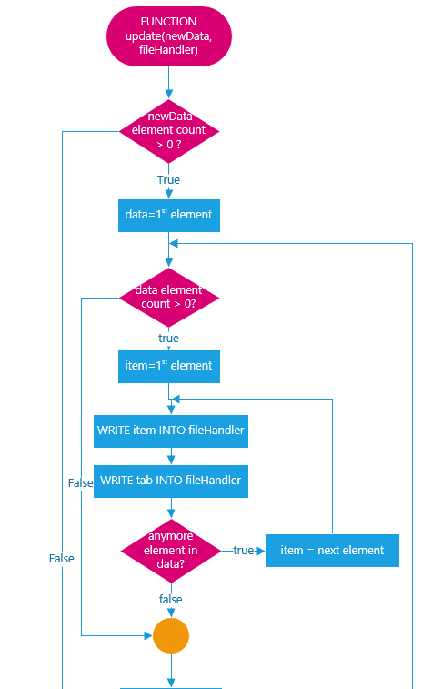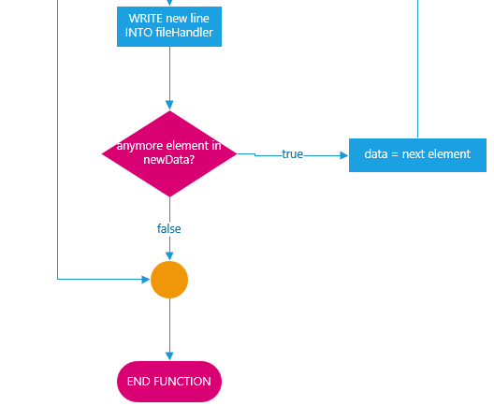 Part inventory tracking

Pseudocode:

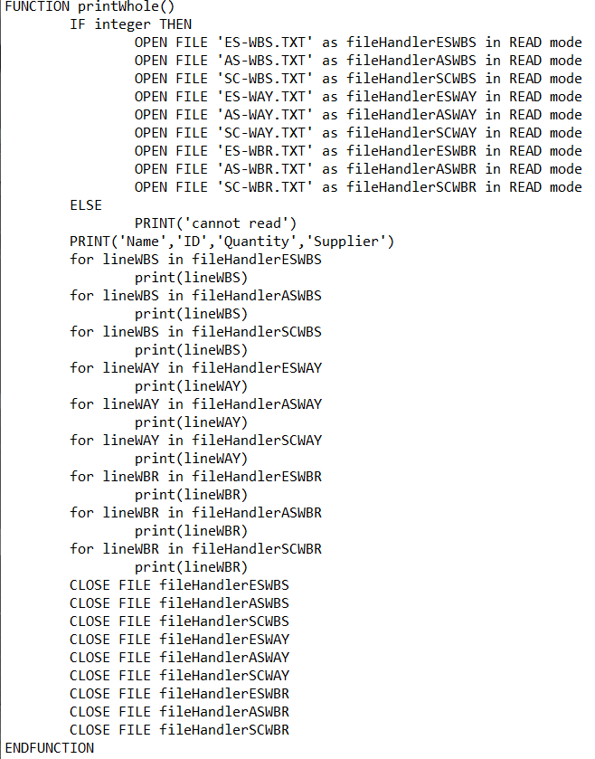

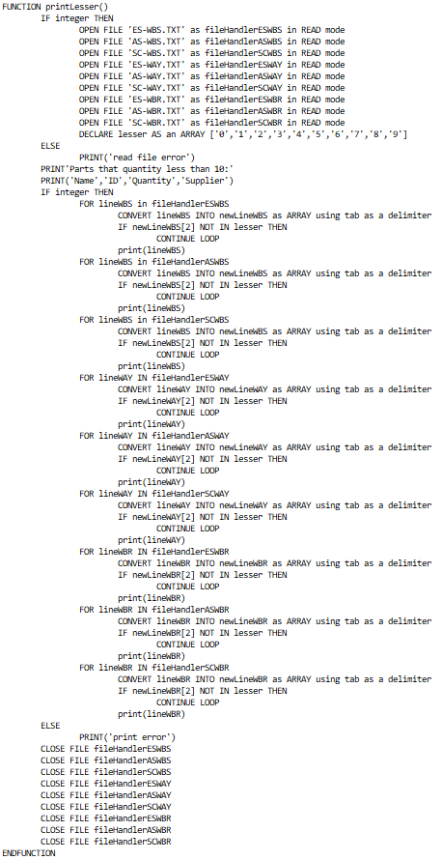

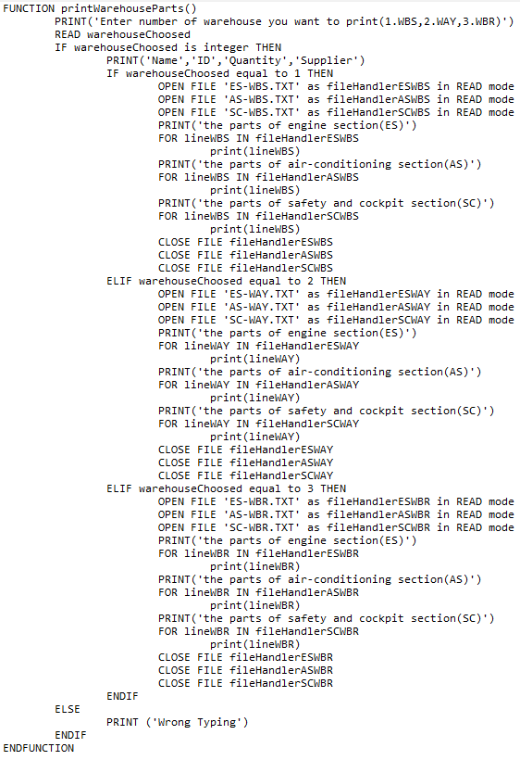

Flowchart:

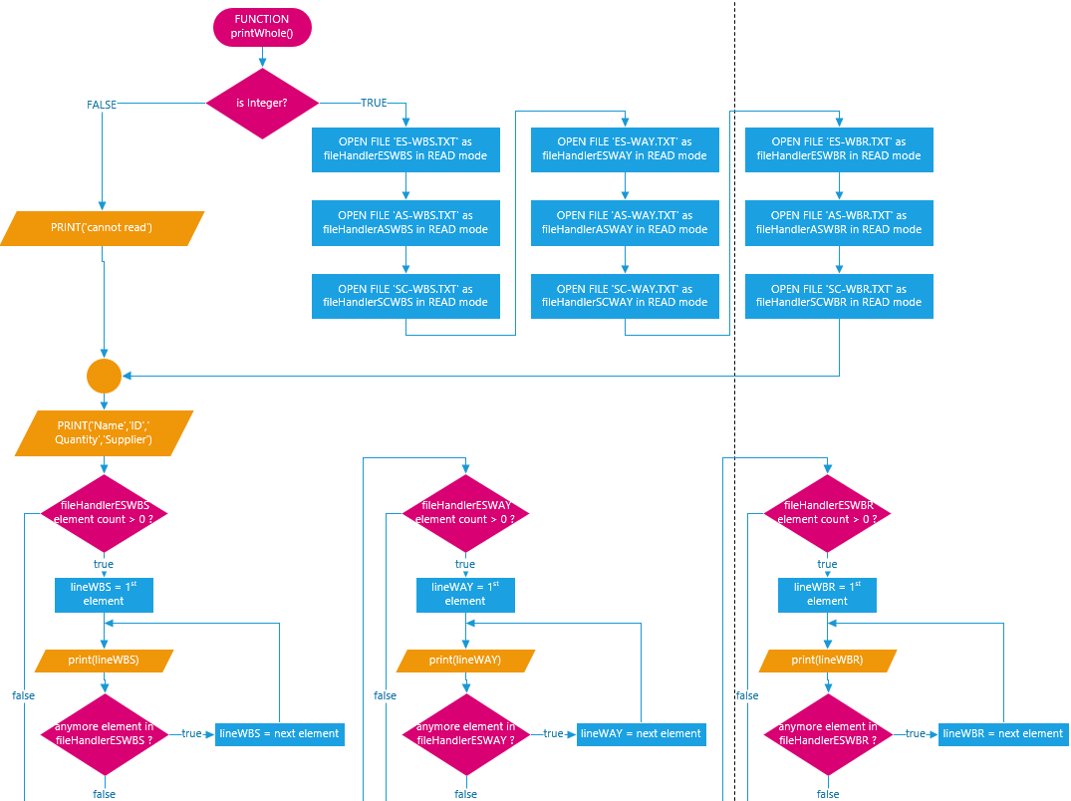printWhole():

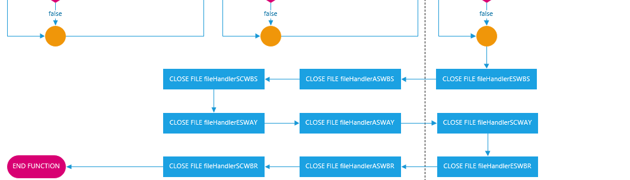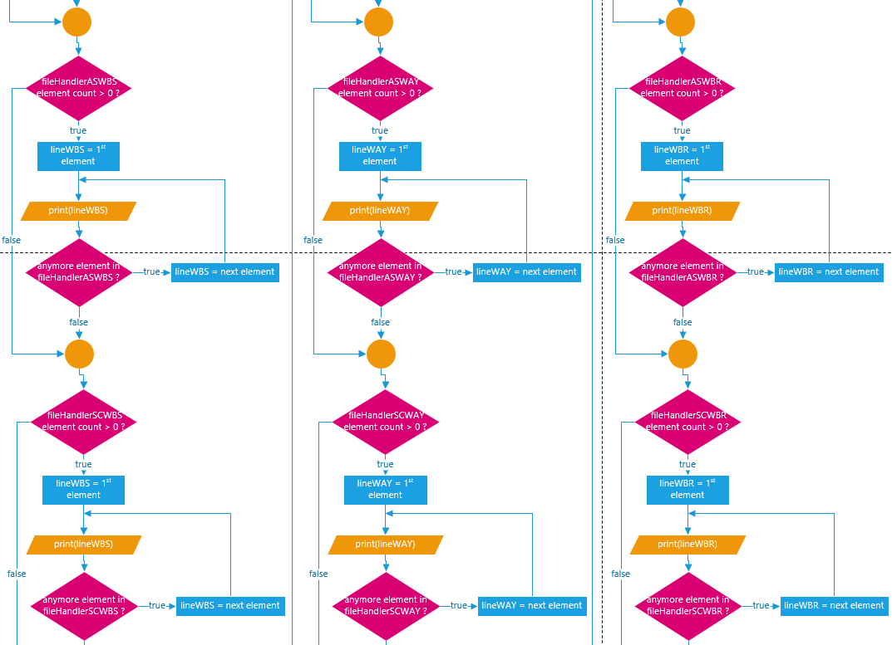

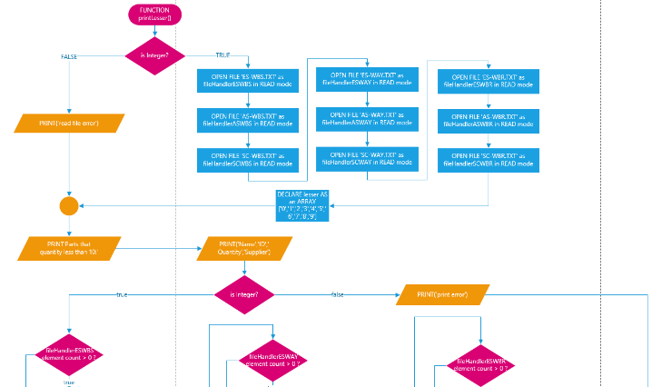printLesser():

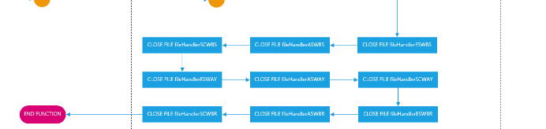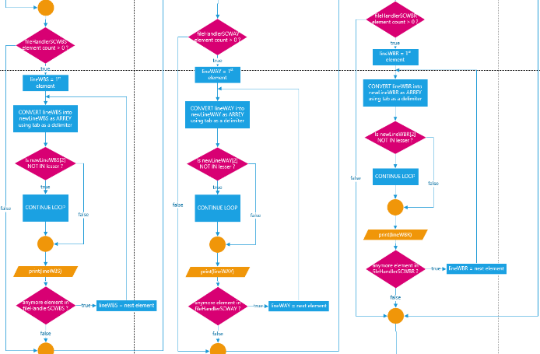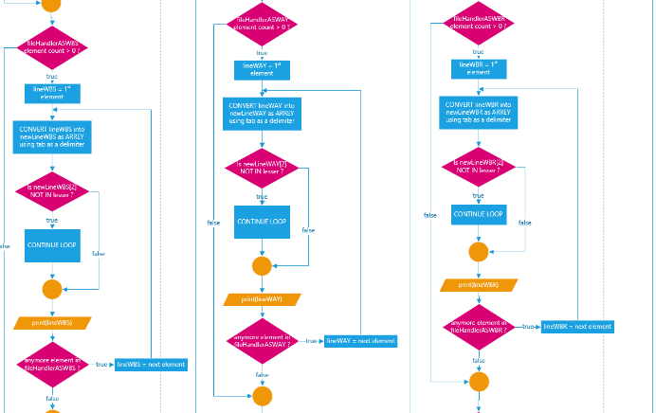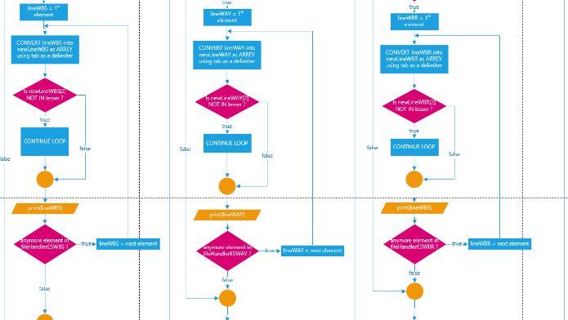

printWarehouseParts():

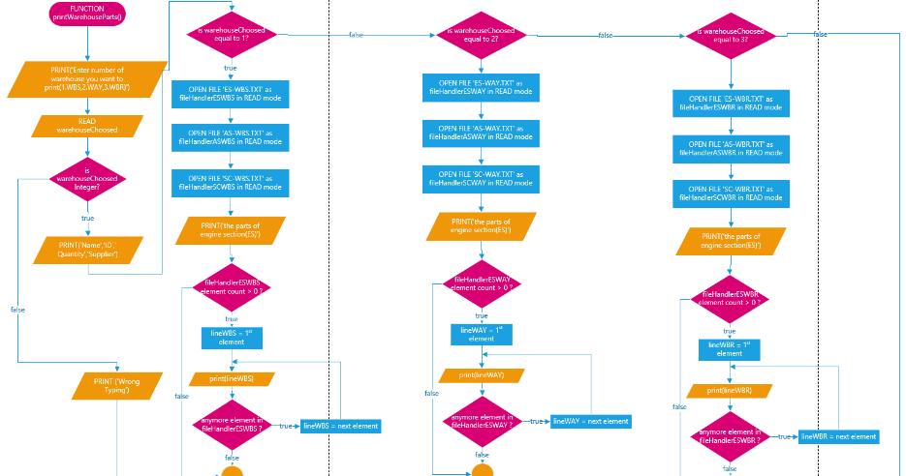

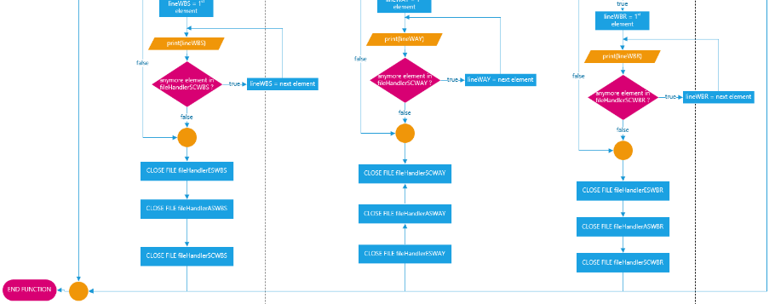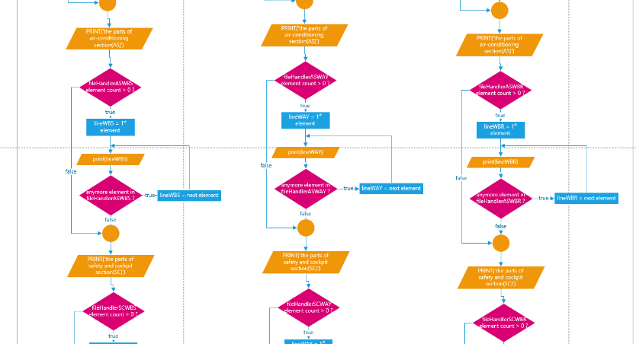

Searching Functionalities

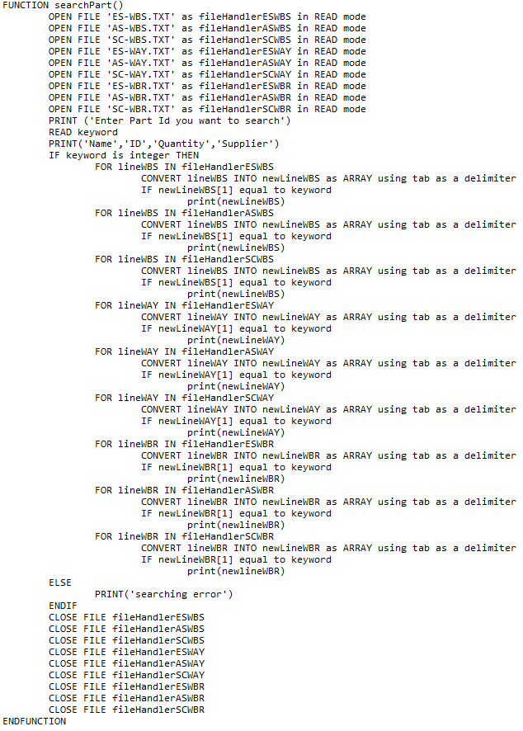Pseudocode:

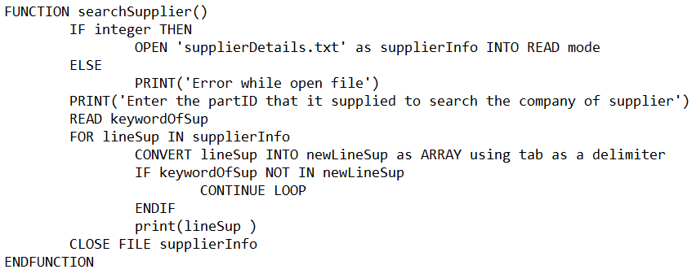 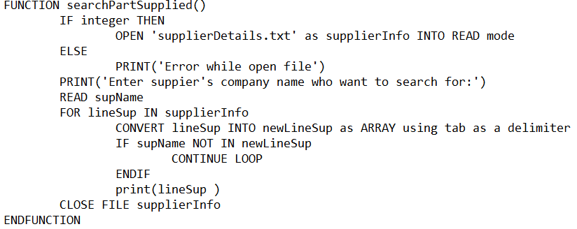

Flowchart:

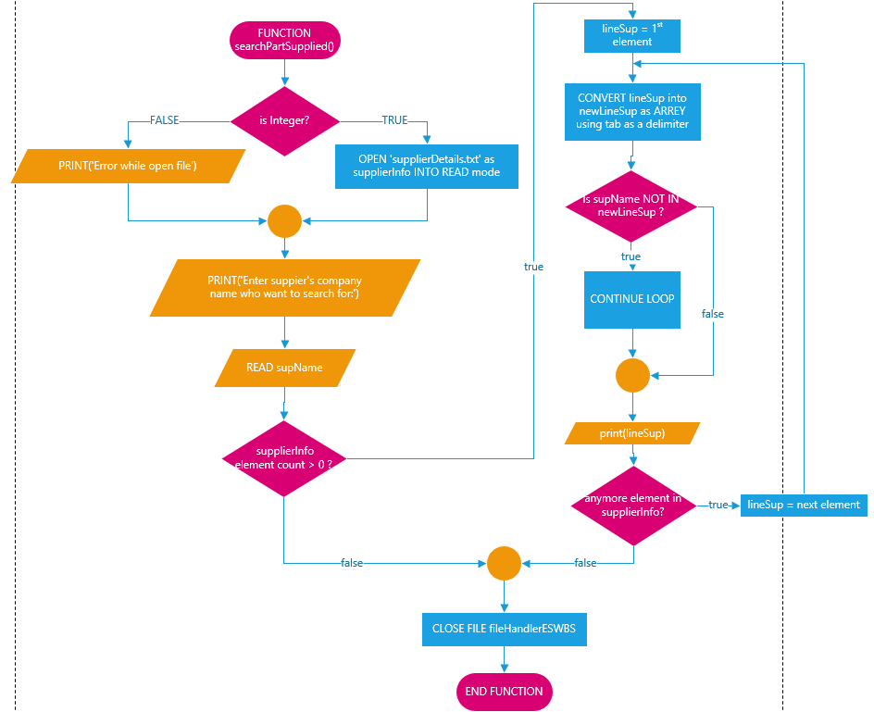searchPartSupplied():

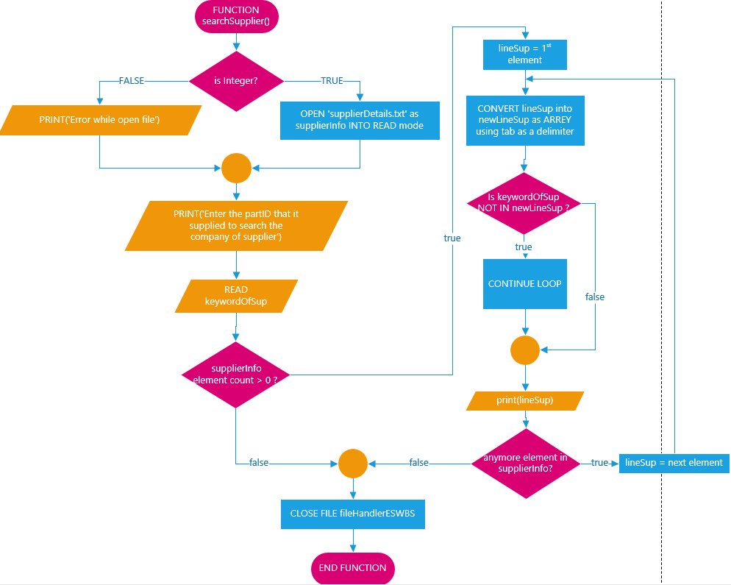searchSupplier():

searchPart():

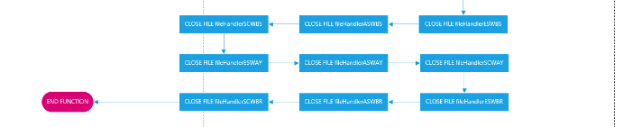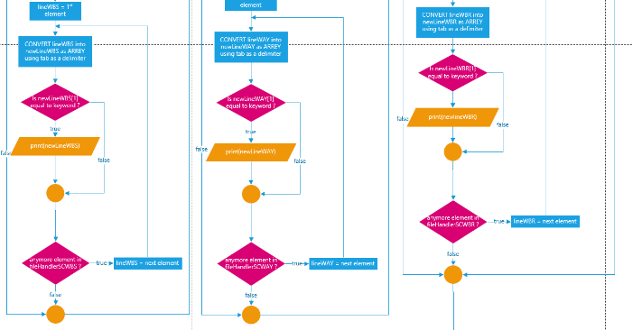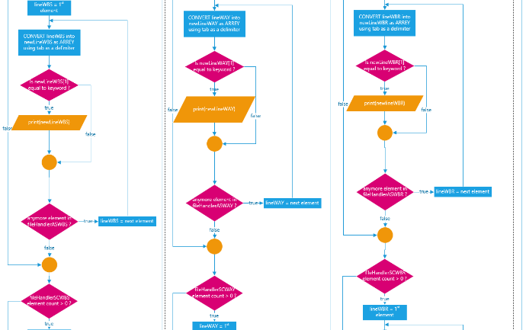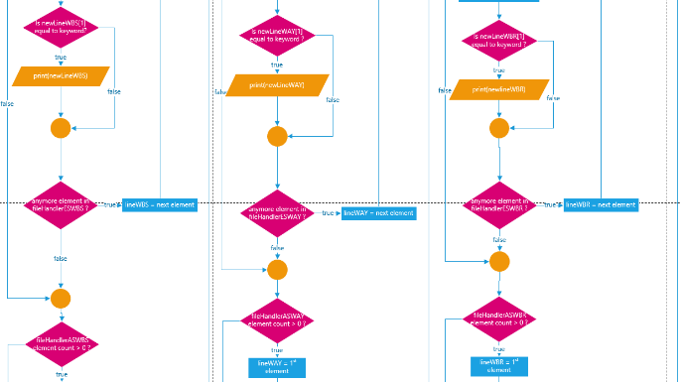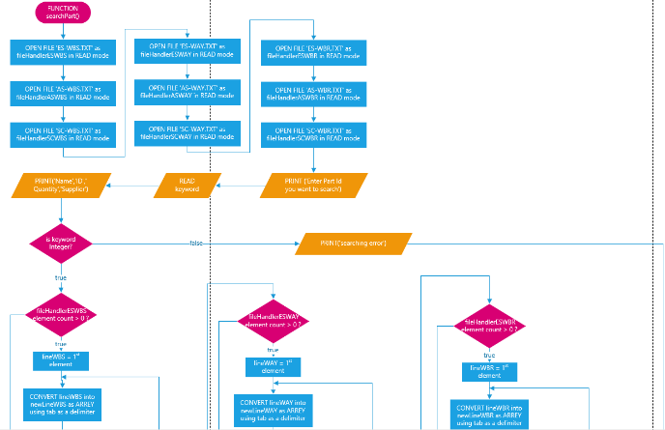

Menu Function

Pseudocode:

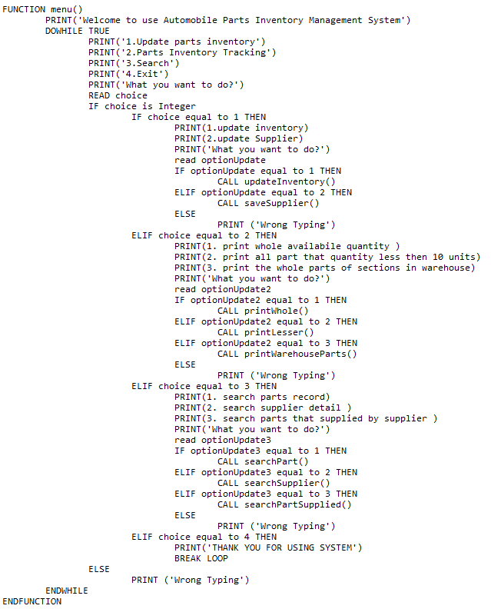

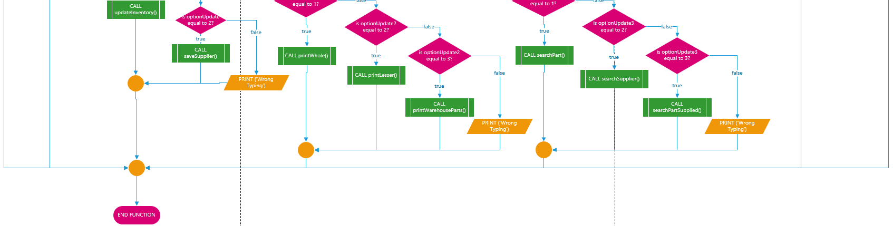menu():

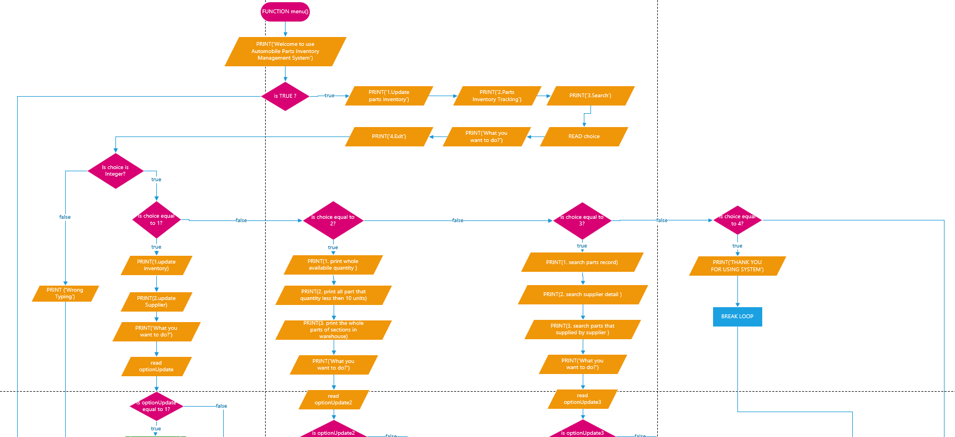

**Program source code and explanation**

Function inventory()

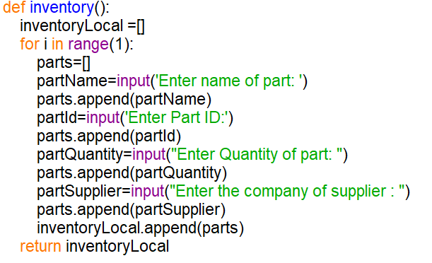

Function inventory() is used to allow users to input the details of parts. All of the data will append into parts and after all data have store into parts then the parts will be appending into inventoryLocal.

Function supplier()

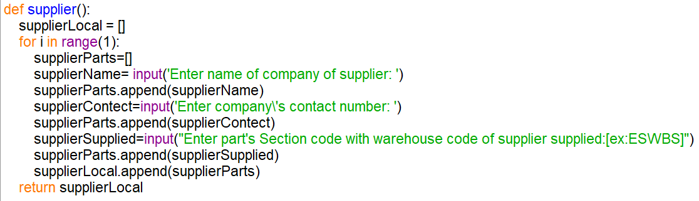

Function supplier() is used to allow users to input the data , append into supplierParts and append supplierParts into supplierLocal.

Function update(newData,fileHandler)

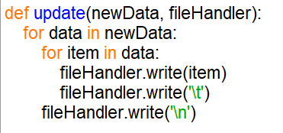

Function update(newData,fileHandler) is used to update the list. If there have element inside the data, the item with a tab will step by step write into the fileHandler. Then the system will write a new line before reading the next element of newData.

Function saveInventoryWBS(), saveInventoryWAY(), and saveInventoryWBR()

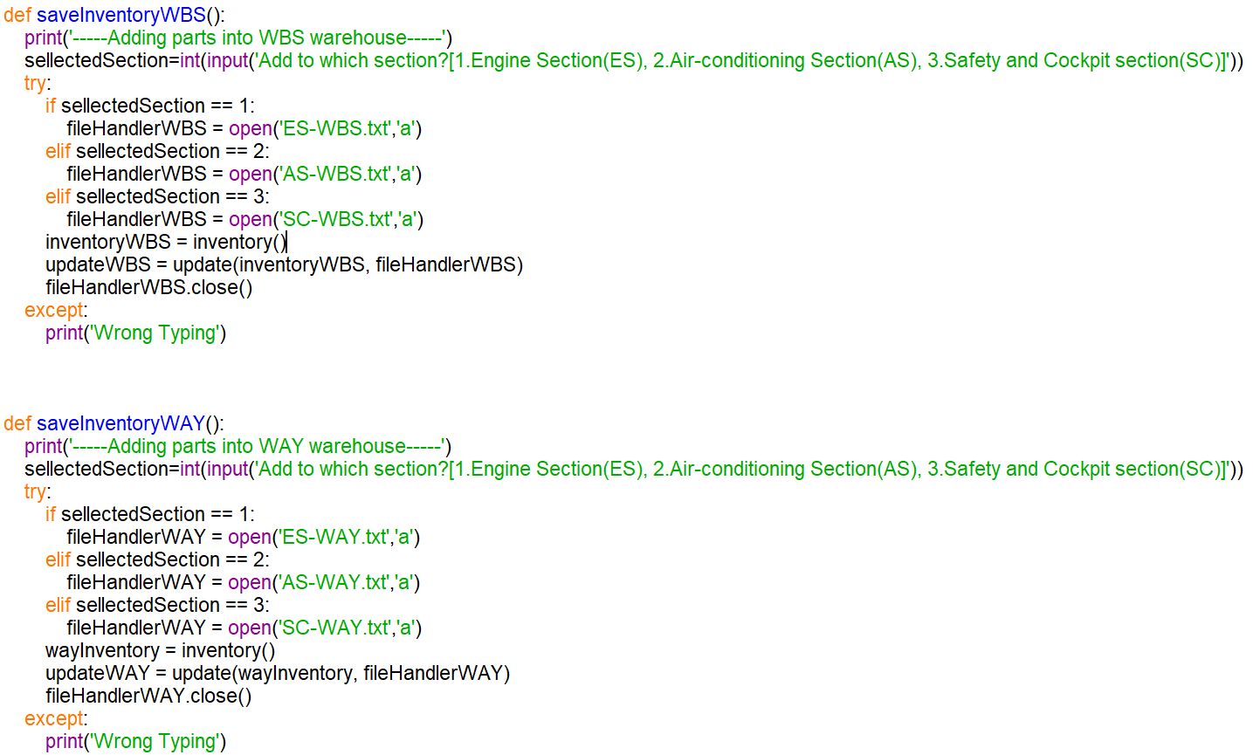 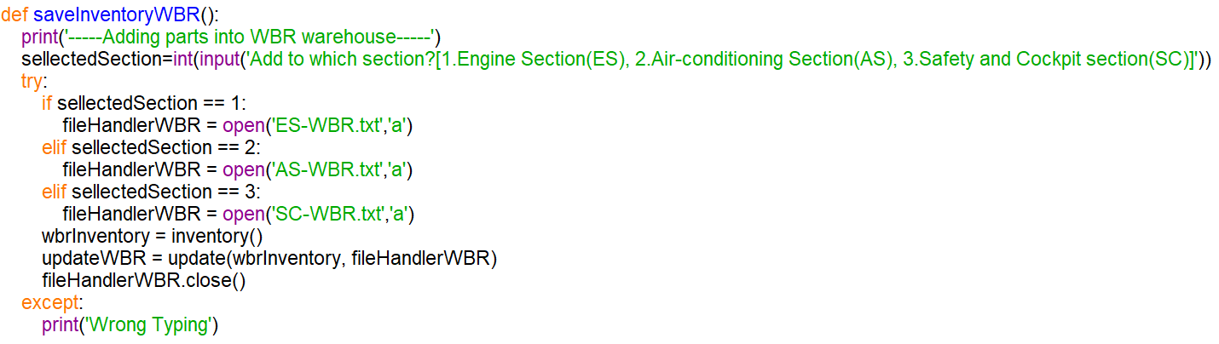

Three of the functions are almost same function, the system ask user to choose which section they need to upload in different warehouse. There are used for calling out the current files and call inventory () function with a variable to get the input from users. After that, the system stores the information through call the update (newData, fileHandler) function with the current variable of different txt file.

Function editQuantityWBS(), editQuantityWAY(), and editQuantityWBR()

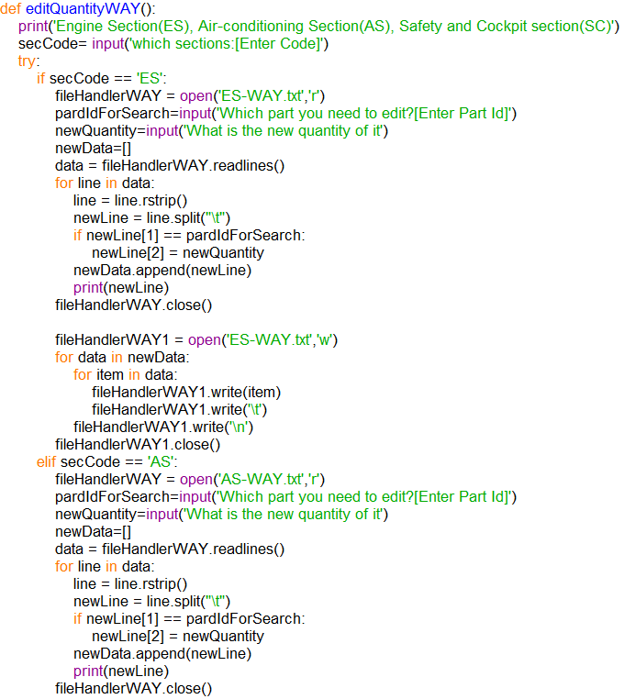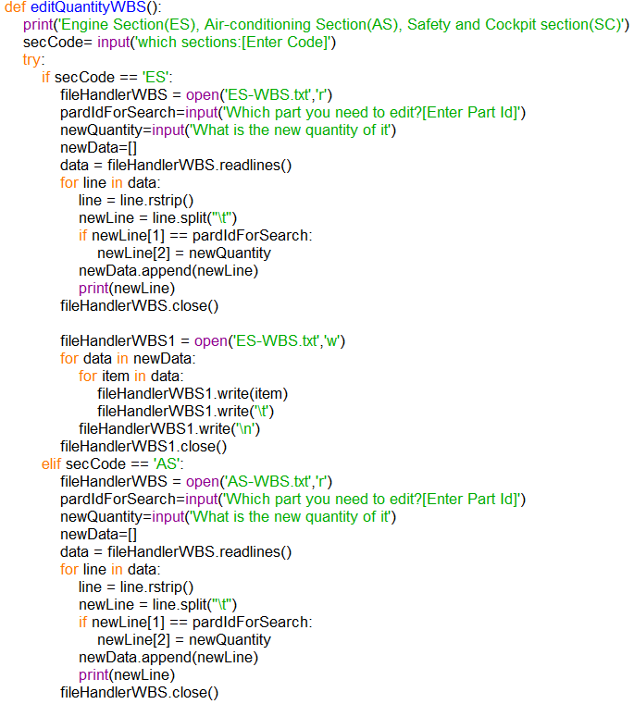

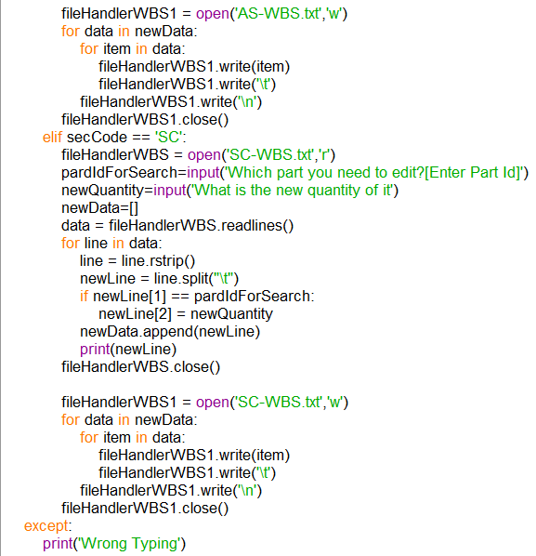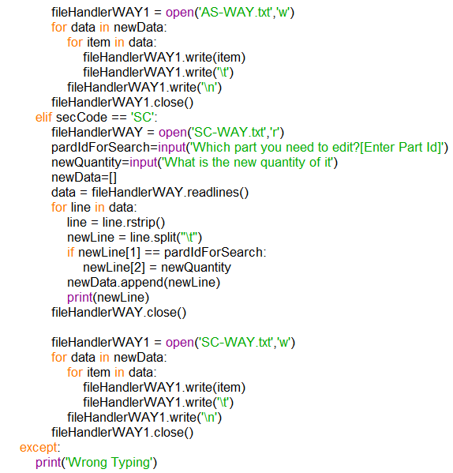

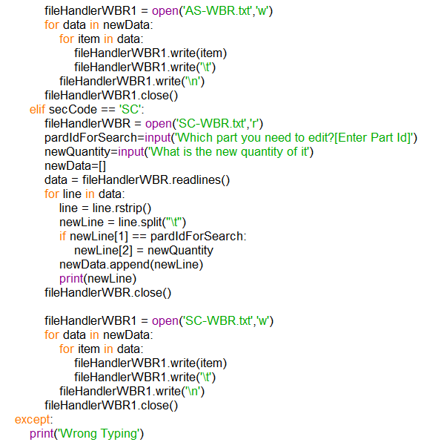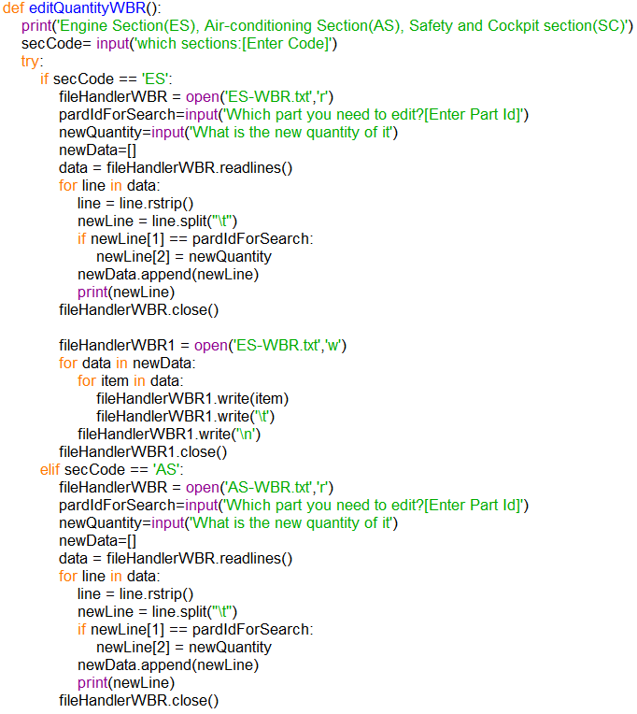Three of the functions are almost same function, there are used for calling out the current files and ask the user to input the part’s id as pardIdForSearch and the new quantity as newQuantity that they want to change. If the system found the partIdForSearch is inside the file, the quantity of the part will be replaced to newQuantity. Then system will call the current file again and update the newQuantity into the file

Function updateInventory()

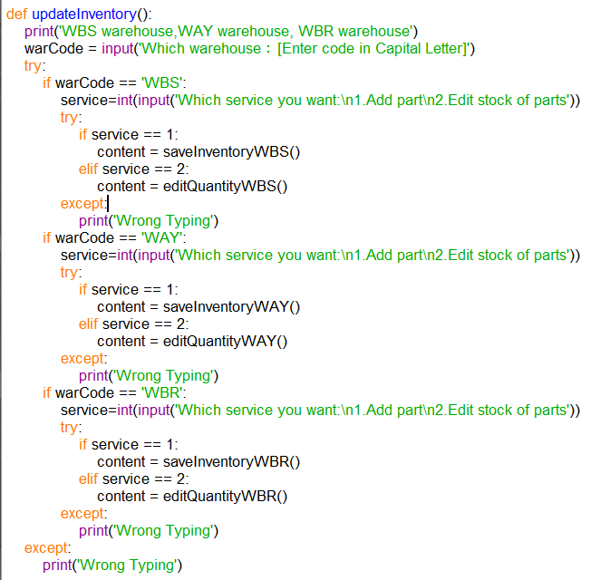

This function is used to create parts inventory, update Inventory’s quantity. The user can choose the part’s warehouse that they want to edit before running through the function of save inventory or edit quantity.

Function saveSupplier()

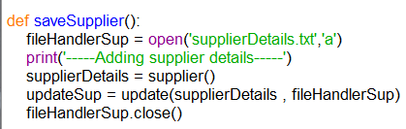

This function is used to append the details of supplier that been store at the supplierDetails into the txt file named supplierDetails

Function printWhole()

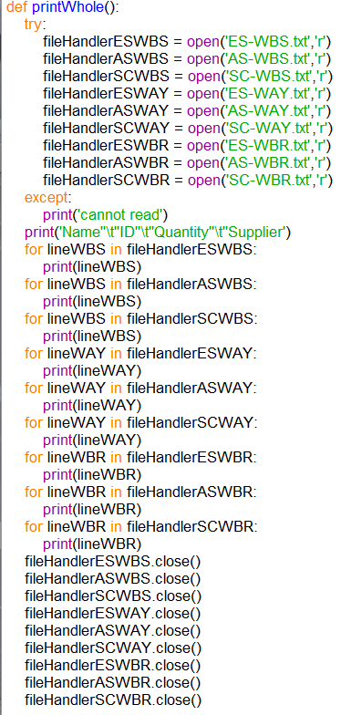

This function is use for printing all the parts that stored inside the company. The system needs to open all txt files, read and print line by line of them.

Function printLesser()

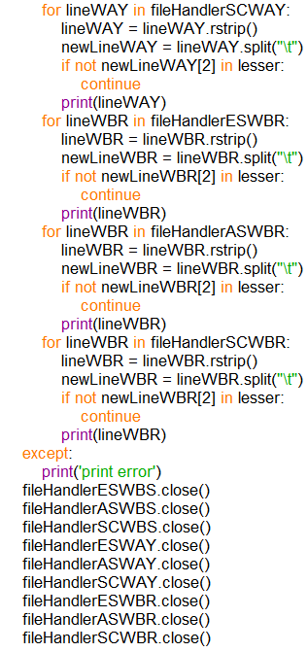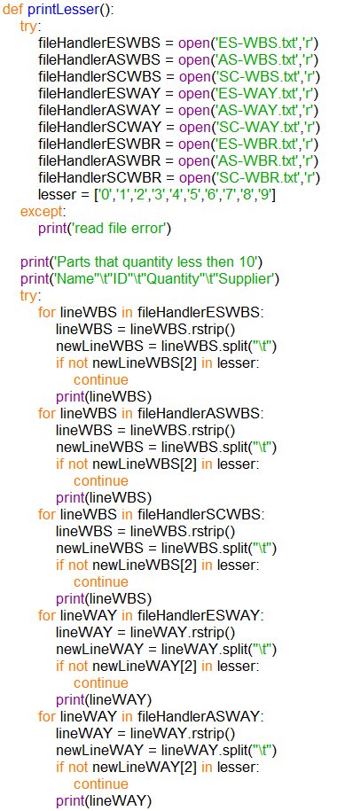

This function is use for printing all the parts which is almost out of stock. If the third element of the lines are not equal to the element of less then it will been skip, the other lines will been print.

Function printWarehouseParts ()

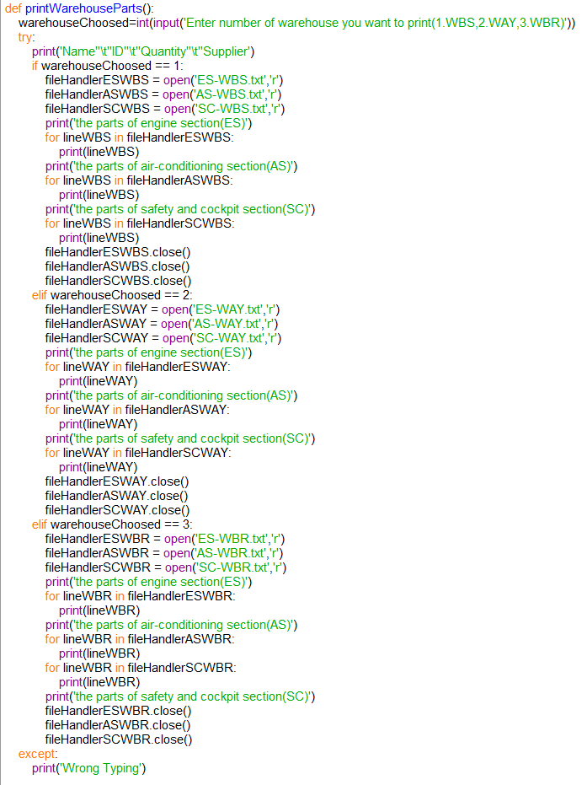

This function is used for printing all the details of parts inside the warehouse which selected by user according to the different sections. It will clearly be shown the parts according their sections.

Function printWarehouseParts ()

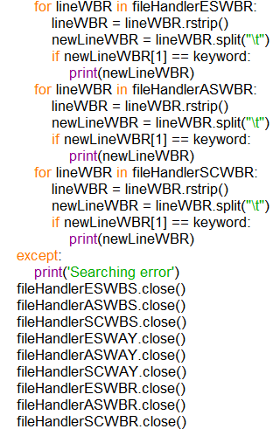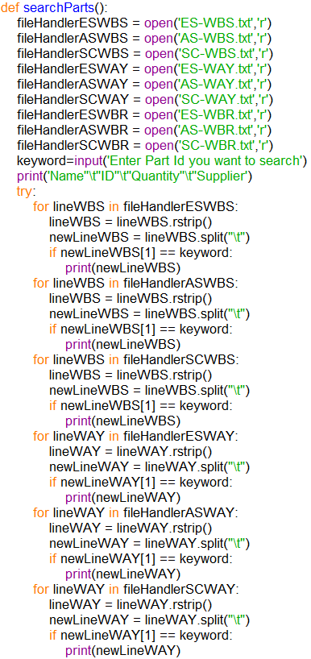

This function will require users to input the part id as keyword. It will be looking towards all the lines of files. If the second element of the lines is equal to the keyword then it will been print, the other lines will been skip.

Function searchSupplier ()

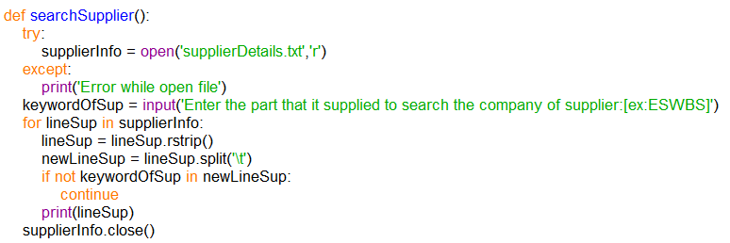

This function will open the supplierDetails.txt file and ask users to input keywordOfSup for search the suplier details. If there are not the keywordOfSup inside the line then it will be skip.

Function searchPartSupplied ()

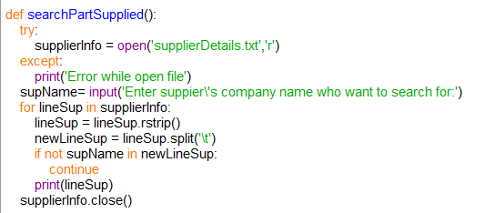

This function will open the supplierDetails.txt file and ask users to input supName for search the parts that suplier supplied. If there are not the supName inside the line then it will be skip.

Function menu ()

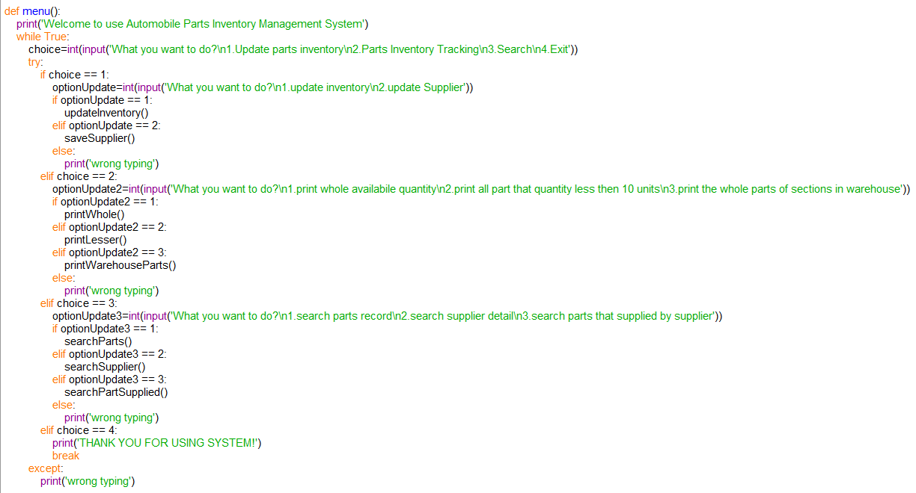

It is the main function of this system to run all the other function. Since it has the while loop on the top, then the function will not stop repeating until break the loop.

Screenshots of sample input/ output and explanation

The input/ output of the program:

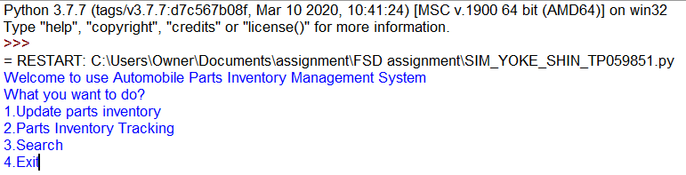

This screenshot is shown the menu() function that show all three update, print,and searching function as options to choose by the users.Also, users can also enter ‘4’ to exit the system.

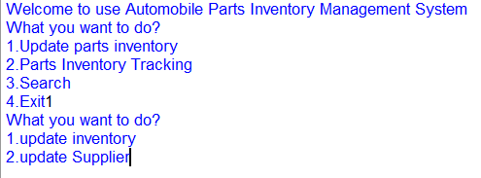

This screenshot is the resalt of type ‘1’. It means the user can enter either ‘1’ or ‘2’ for update the record of inventories or update the record of suppliers.

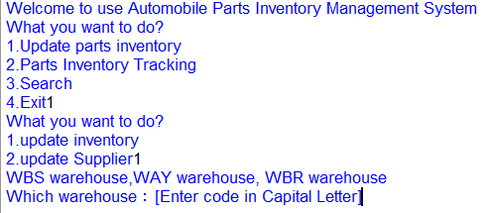

It is the screenshot of the updateInventory() function while the user has choose option ‘1’ to update the record of inventory. Users must enter the code of warehouse to update the record of the warehouse.

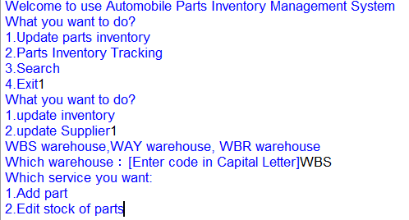

It is the screenshot of the output of updateInventory() function while the user has enter ‘WBS’ that can allow users type ‘1’ or ‘2’ to add new part’s detail or edit the quantity of parts.

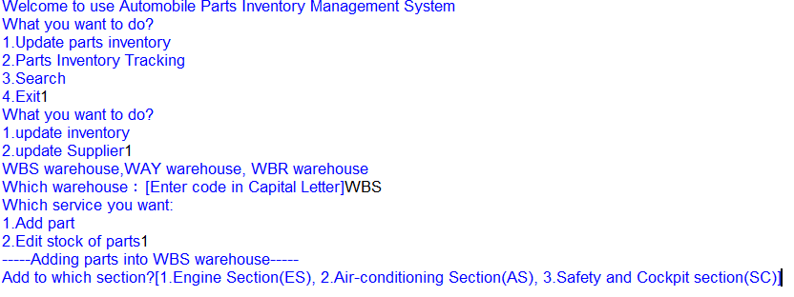

It is the screenshot of the output of updateInventory() function while the user has enter ‘1’ to add new part and shown 3 names of section to allow user to choose.

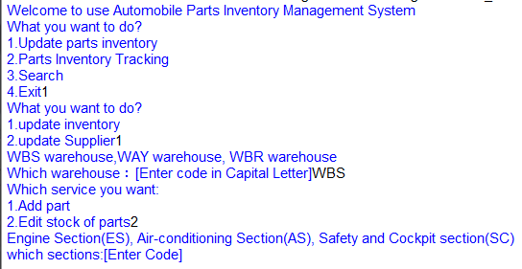

It is the screenshot of the output of updateInventory() function while the user has entered ‘2’ to edit the quantity of part and shown 3 names of section to allow user to choose the section’s.

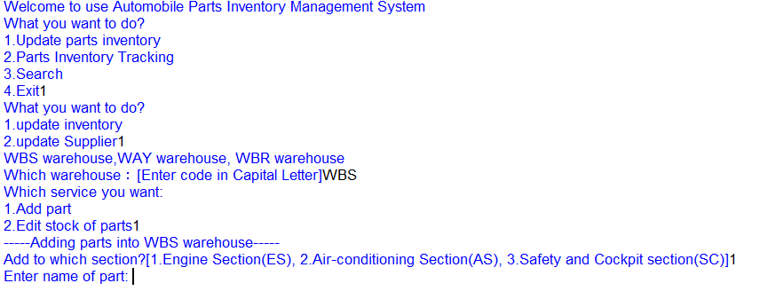

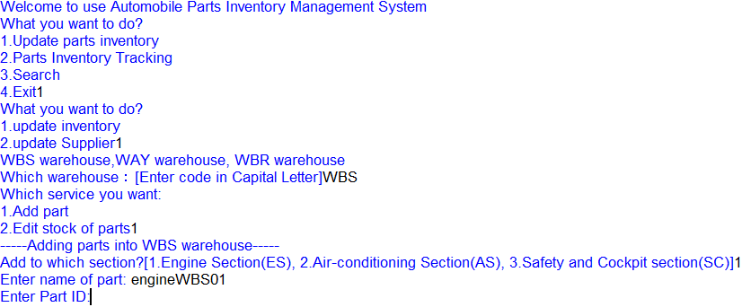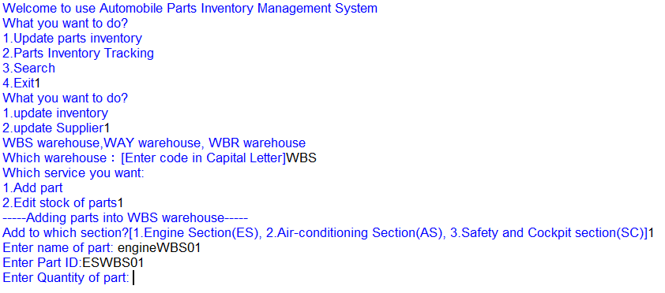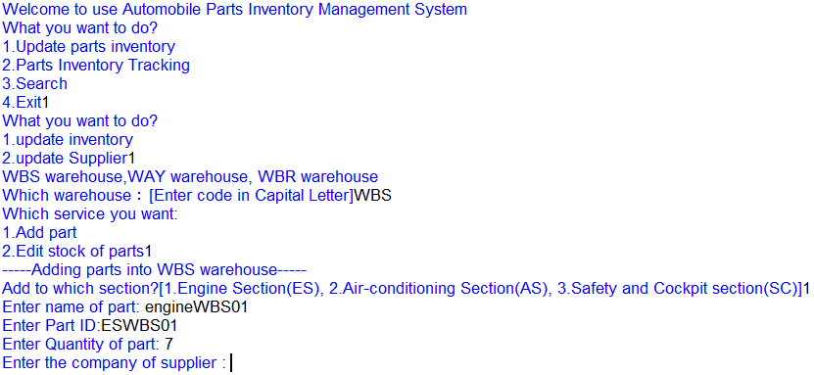

There are the screenshot of inventory() function that let user input the detail of new part’s name , id , quantity, and supplier’s companny name.

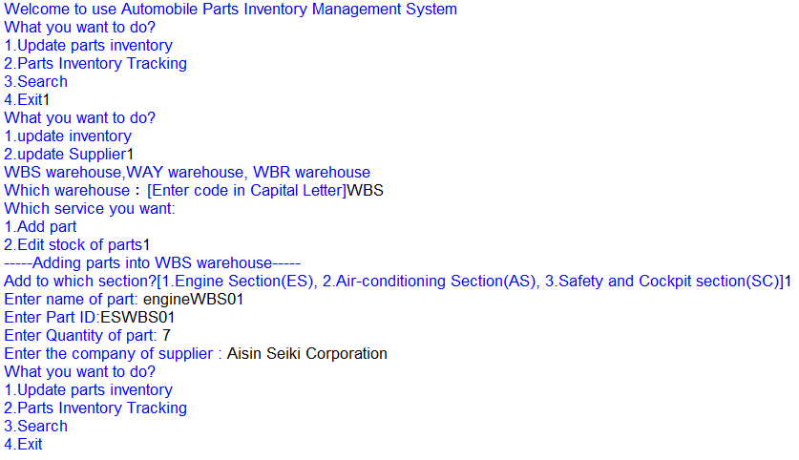

After finish input all the details of part will return into the main menu.

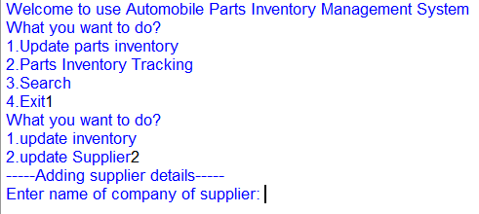

It is the screenshot of the output of saveSupplier() function while the user has choose option ‘2’ to update the record of supplier.It require user to input the name of the supplier’s company.

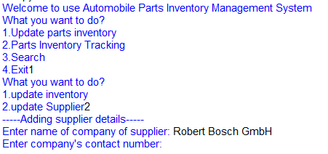

It is the screenshot of the saveSupplier() function that let user input the contact number of new suppliers.

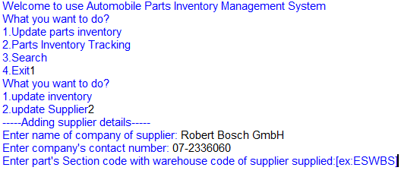

It is the screenshot of the saveSupplier() function that let user input the code of section code with warehouse code likes ESWBS that the supplier supplied.

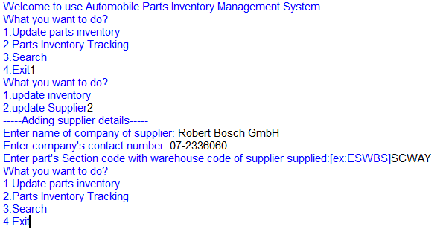

After finish input all the details of supplier will return into the main menu.

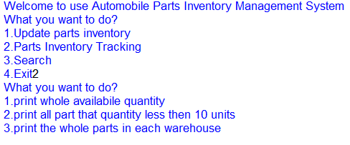

This screenshot is the result of type ‘2’. It can allow user to choose print whole available quantity, print all parts that is almost out of stock, or print the parts according with the option of warehouse.

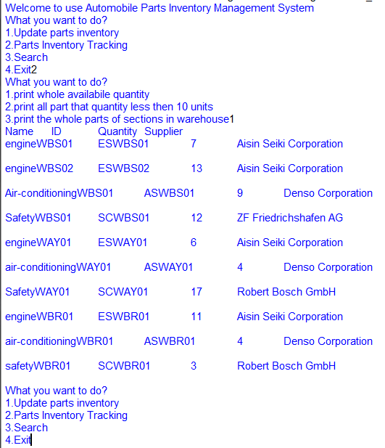

This screenshot is the result of type ‘1’ and active the printWhole() function. It has print all the parts detail that been store in all txt file.

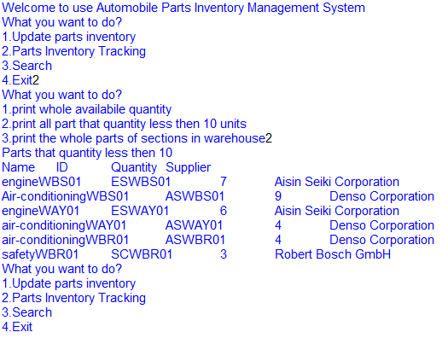

This screenshot is the result of type ‘2’ and active the printLesser() function. It has print all the part’s details which its quantity is less then 10 units.

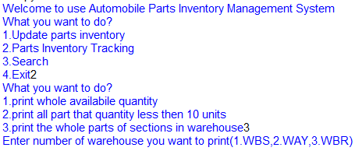

This screenshot is the result of type ‘3’ and allow user to choose which warehouse’s parts they want to print.

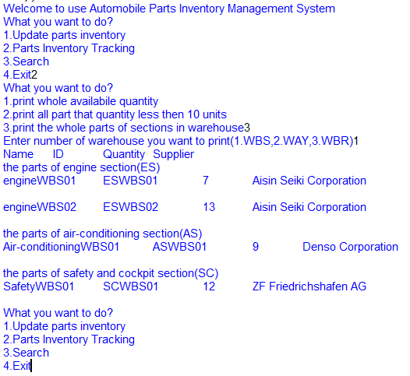

This screenshot is the result of type ‘1’. It has print all the part’s details which belong to WBS warehouse.

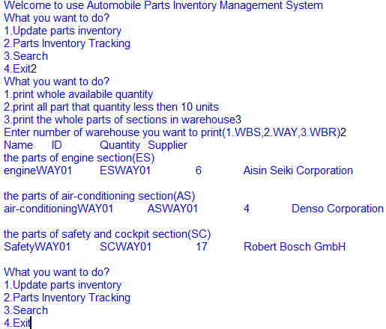

This screenshot is the result of type ‘2’. It has print all the part’s details which belong to WAY warehouse.

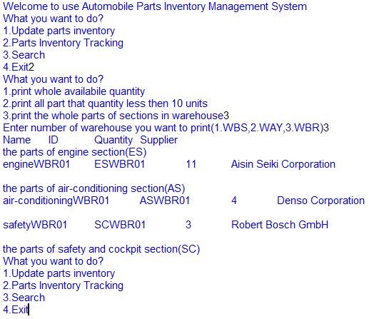

This screenshot is the result of type ‘3’. It has print all the part’s details which belong to WBR warehouse and return to the main menu.

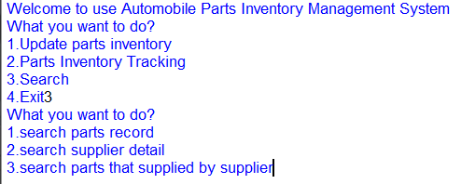

This screenshot is the result of type ‘3’. It allow user to search the details of part, search the details of supplier, or search the parts that the supplier supplied.

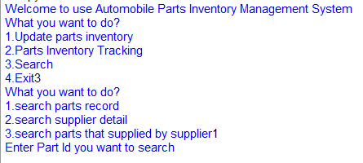

This screenshot is the result of type ‘1’. It require user to enter part id for search the detail of part.

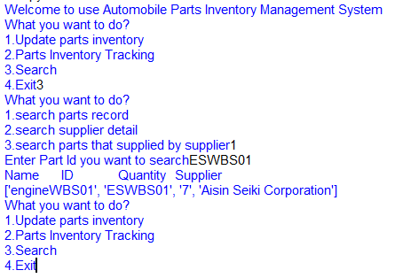

The screenshot is shown the result after enter the part id, it successfully print the details of part.

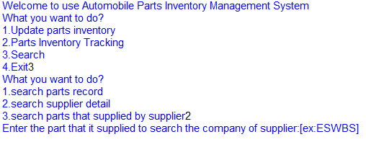

This screenshot is the result of type ‘2’. It require user to enter the part id with the warehouse code for search the detail of supplier.

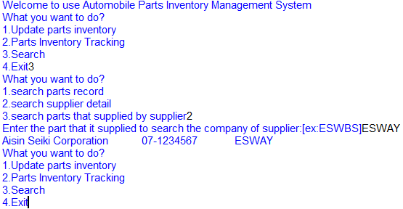

This screenshot is shown the result after the user type the special code of part’s section and warehouse. It has print the details of the supplier which the user want to search.

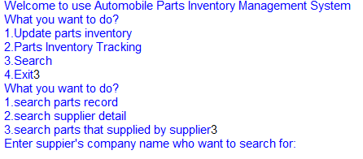

This screenshot is the result of type ‘3’. It require user to input the suppplier’s company name to search the detail of the supplier.

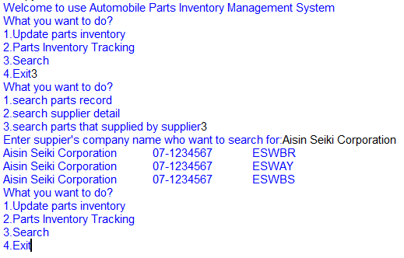

This screenshot is the result of enter the name of the supplier’s company. It has print all the part’s section that the supplier supplied.

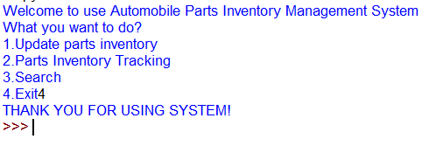

This screenshot is the resalt of type ‘4’. It means the user want to exit the system and it will break the loop of repeat running the system.

**Conclution**

In conclution, the proposed flowchart , pseudocode and code met all the requirement and fulfilled the made assumptions. The purpose of the research were reached at the end. The researcher had added a large amount of knowledge regarding coding. This report had well documented the designs of the proram.

**Reference**